**DAILY ONLINE ACTIVITIES SUMMARY**

|  |  |  |  |  |  |  |  |  |
| --- | --- | --- | --- | --- | --- | --- | --- | --- |
| **Date:** | **28/05/2020** | | | | | **Name:** | **NAIPUNYA VINOD NAIK** | |
| **Sem & Sec** | **IV SEM & A SECTION** | | | | | **USN:** | **4AL18CS050** | |
| **Online Test Summary** | | | | | | | | |
| **Subject** | | **1) MICROCONTROLLER AND EMBEDDED SYSTEMS**  **2) VYAVAHARIKA KANNADA** | | | | | | |
| **Max. Marks** | | **1)20**  **2)50** | | **Score** | | | 1. **20** 2. **48** | |
| **Certification Course Summary** | | | | | | | | |
| **Course** | **INTRODUCTION TO CLOUD COMPUTING** | | | | | | | |
| **Certificate Provider** | | | **Cognitive.ai with IBM** | | **Duration** | | | **6 HRS** |
| **Coding Challenges** | | | | | | | | |
| **Problem Statement: 1)** [In an array X of size M where the array elements contain values from 1 to M with duplicates, the task is to find total number of sub arrays which start and end with the same element.](https://github.com/orgs/alvas-education-foundation/teams/2nd-year/discussions/85)  **2)** [C program to find digital root of a number](https://github.com/orgs/alvas-education-foundation/teams/2nd-year/discussions/84) | | | | | | | | |
| **Status: EXECUTED** | | | | | | | | |
| **Uploaded the report in Github** | | | | | **YES** | | | |
| **If yes Repository name** | | | | | <https://github.com/naipunya-naik/lockdown-coding/blob/master/JAVA%20CODING/subarray.java>  <https://github.com/naipunya-naik/lockdown-coding/blob/master/C%20CODING/digitalroot.c> | | | |
| **Uploaded the report in slack** | | | | | **YES** | | | |

Online Test Details: (Attach the snapshot and briefly write the report for the same).

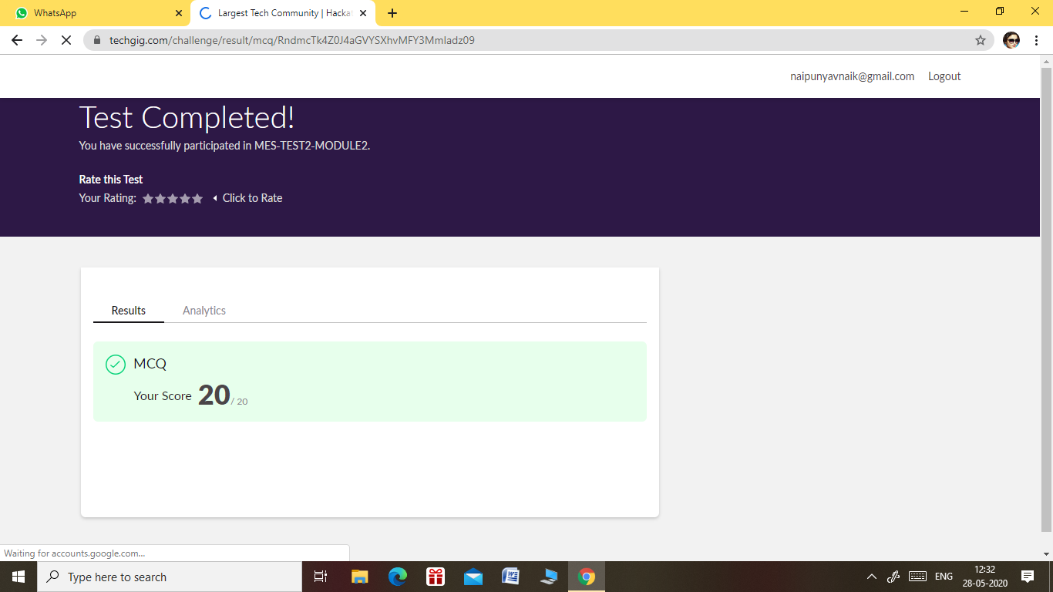

1. THE 2ND I.A TEST OF MICROCONTROLLER AND EMBEDDED SYSTEMS SUBJECT WAS CONDUCTED ON 28 MAY 2020.
2. SUBJECT: MICROCONTROLLER AND EMBEDDED SYSTEMS
3. NO. OF QUESTIONS:- 20
4. TOTAL MARKS:- 20
5. DURATION:- 40 MIN
6. EACH QUESTION CARRIED 1 MARK
7. START TIME:- 12.00 PM
8. END TIME:- 12.40 PM

2)

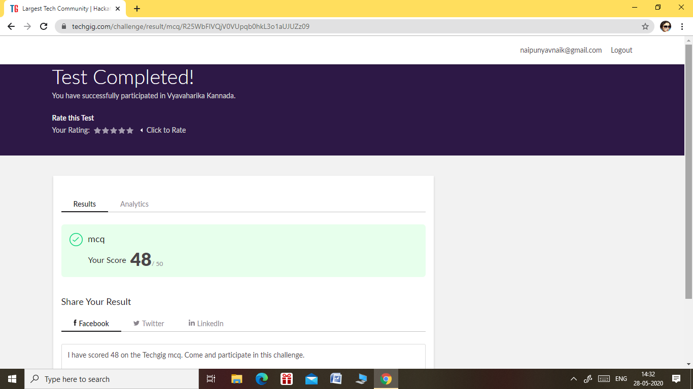

1. THE 1ST I.A TEST OF VYAVAHARIKA KANNADA SUBJECT WAS CONDUCTED ON 28 MAY 2020.
2. SUBJECT: VYAVAHARIKA KANNADA
3. NO. OF QUESTIONS:- 30
4. TOTAL MARKS:- 50
5. DURATION:- 50 MIN
6. EACH QUESTION CARRIED 1 MARK
7. START TIME:- 2.00 PM
8. END TIME:- 2.50 PM

Certification Course Details: (Attach the snapshot and briefly write the report for the same).

CERTIFICATION COURSE NAME :- INTRODUCTION TO CLOUD COMPUTING.

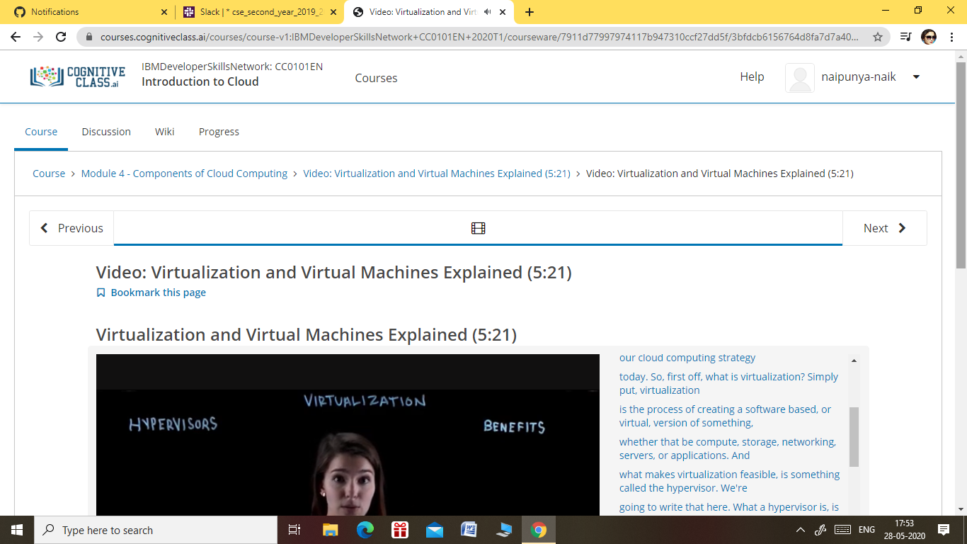

TOPICS COVERED TODAY:-

* MODULE 4:-COMPONENTS OF CLOUD COMPUTING

### MODULE 5 - CLOUD COMPUTING STORAGE AND CONTENT DELIVERY

### NETWORKS

### MODULE 6 - EMERGENT TRENDS, CLOUD NATIVE, DEVOPS AND APPLICATION MODERNIZATION

Coding Challenges Details: (Attach the snapshot and briefly write the report for the same).

1. PROBLEM STATEMENT:- In an array X of size M where the array elements contain values from 1 to M with duplicates, the task is to find total number of sub arrays which start and end with the same element.

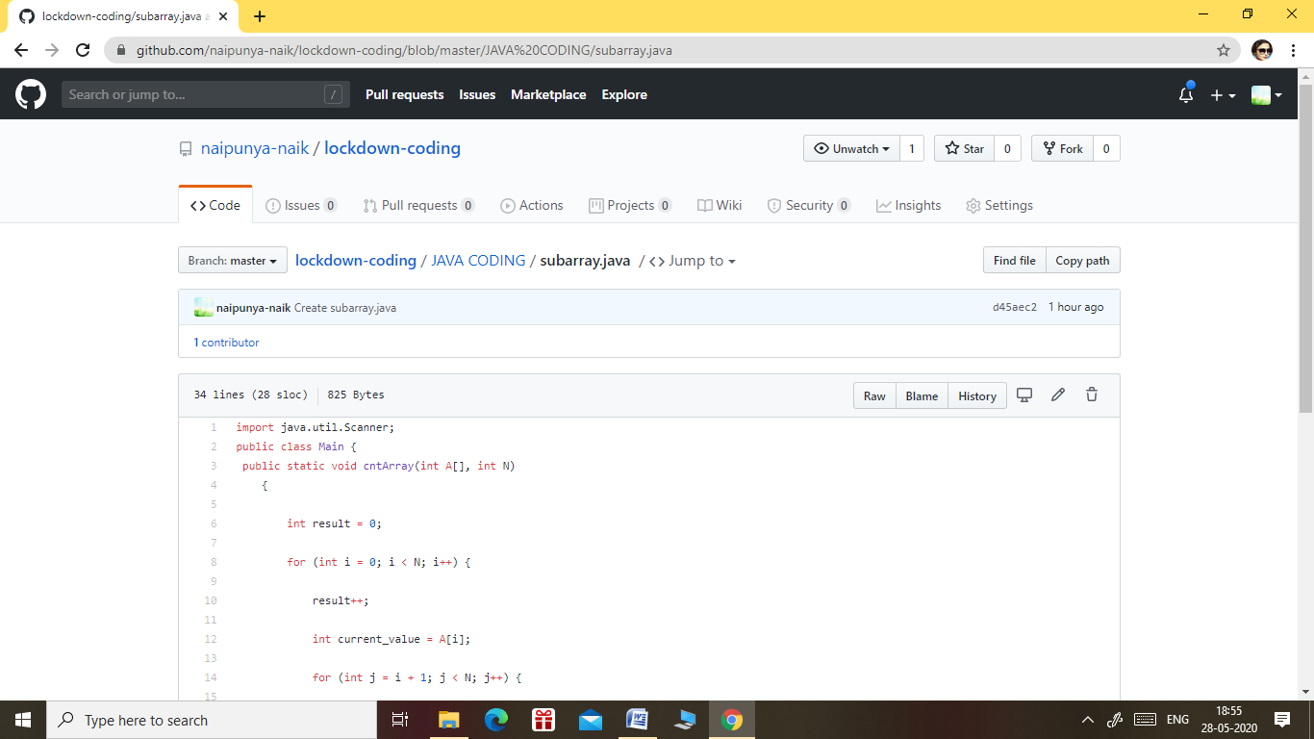

GITHUB REPOSITORY LINK:-

<https://github.com/naipunya-naik/lockdown-coding/blob/master/JAVA%20CODING/subarray.java>

1. PROBLEM STATEMENT:- [C program to find digital root of a number](https://github.com/orgs/alvas-education-foundation/teams/2nd-year/discussions/84).

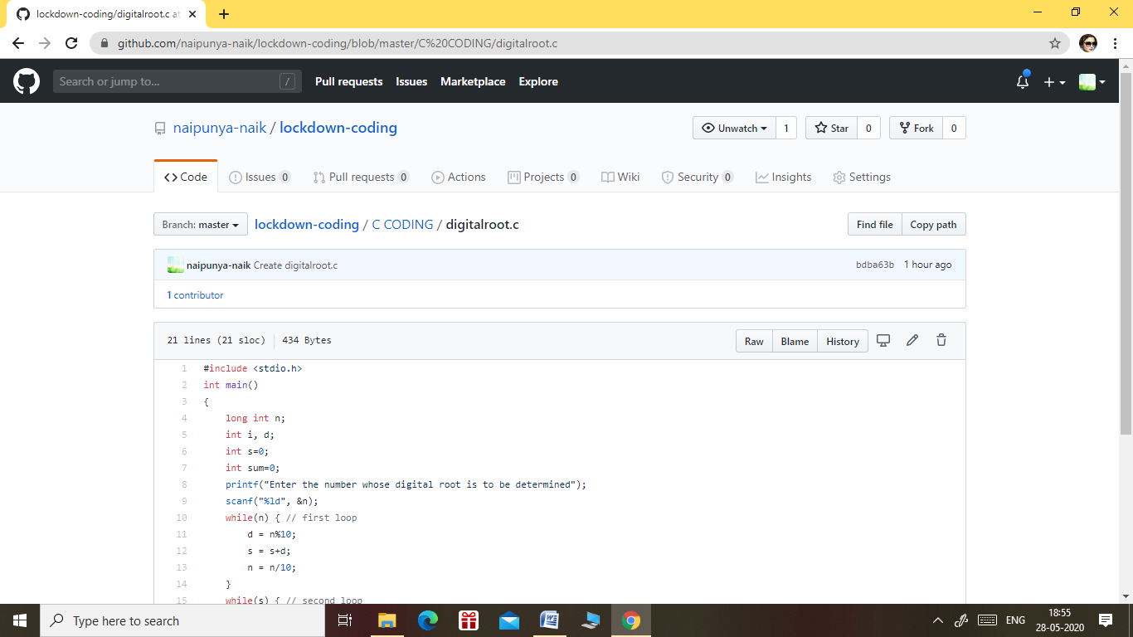

GITHUB REPOSITORY LINK:-

<https://github.com/naipunya-naik/lockdown-coding/blob/master/C%20CODING/digitalroot.c>